Predicting Human Preference Between Two Chatbot Responses
Kaggle “LLM Classification Finetuning” · ModernBERT shared-weight bi-encoder · Project report
Rohan · October 2026

1. Summary
The task is to predict which of two chatbot answers a human preferred (A, B or tie), scored by multi-class log loss. I built a feature-based baseline first, then fine-tuned a ModernBERT-base model in PyTorch as a shared-weight bi-encoder. The final submission scored 1.01820 on the public leaderboard (62nd of 239), against 1.0737 for the baseline and about 1.098 for a model that only outputs class frequencies. The gain is real but modest: the model picks up style and quality cues but not correctness reasoning. Most of the engineering effort went into data defects, compute budgeting, using two GPUs, and packaging the model for an offline code competition.
Approach | Log loss | Notes
Predict class frequencies (35% / 34% / 31%) | ≈ 1.098 | Reference floor: a model that knows nothing about the text
Length + TF-IDF features, logistic regression | 1.0737 (leaderboard); 1.0704 (5-fold CV) | Only 0.024 below the floor
ModernBERT bi-encoder (final) | 1.0182 (leaderboard); 1.0136 (holdout) | 62 / 239; 0.080 below the floor

2. Problem and data
The training set has 57,477 labelled rows from Chatbot Arena. Each row holds a user prompt, response A, response B and a human verdict (A wins 34.9%, B wins 34.2%, tie 30.9%). Position bias is negligible. Because the metric is log loss, the model must output calibrated probabilities: a confident wrong answer is punished far more than a hedged one. Log loss is the average of −ln(probability given to the true outcome), so a score of 1.0182 means the model assigns on average (geometrically) about 0.36 to what actually happened, versus 0.33 for the floor and 0.34 for the baseline. The numbers look close because human votes are noisy, so the achievable loss is well above zero.
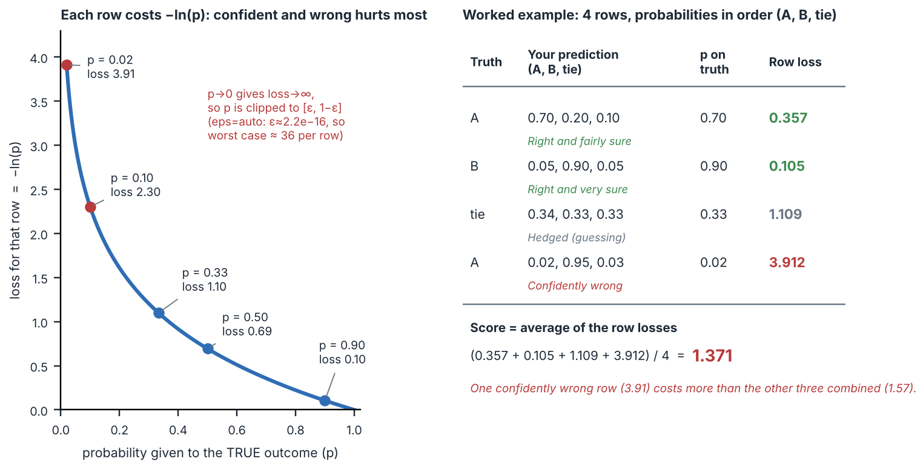
Figure 1. How the metric works. Each row is scored only on the probability given to the outcome that actually happened; the score is the average over rows. With eps=auto, probabilities are clipped to a tiny range set by machine precision so a predicted 0 cannot produce infinity. Submitted rows should sum to 1 (mine do, as softmax outputs).
Conversations can be multi-turn and the text is long-tailed: the median response is about 228 tokens, but the 90th percentile is about 580 and the 99th about 1,460 (measured with the DeBERTa tokenizer). This is a code competition: my notebook is re-run by Kaggle on a hidden test set, so training and inference have to be separated and everything must run reproducibly from a blank kernel.

3. Data defects and how I handled them
- String-encoded lists. The text columns are strings that look like Python lists (one element per turn). I parsed them with the safe ast.literal_eval. It failed on 111 response_a and 120 response_b rows (about 0.2%) because of malformed quote escaping in the source. Rather than drop rows, I fall back to keeping the raw string as one turn. Dropping would not have been consistent anyway, because the test set contains the same defect.
- Lone UTF-16 surrogate characters (corrupted emoji fragments) in 136 prompts and 382 / 359 responses. Python accepts them in a string, but the Rust-based Hugging Face tokenizer rejects them with an unhelpful TextEncodeInput type error. I removed them with a UTF-16 round trip (surrogatepass, then ignore) and verified zero remained. The same cleaning is applied to train and test, byte for byte.

4. Baseline
The baseline used character lengths, their difference and log-ratio, turn count, and TF-IDF cosine similarity between the prompt and each response, fed to a standardised logistic regression with 5-fold stratified CV. I replaced a raw length ratio with a log-ratio after seeing values up to 4,827 caused by near-zero denominators. Its purpose was to prove the whole pipeline end to end (parse, features, CV, submission) and to give me a number to beat. The result, only 0.024 below the floor, shows that surface features carry little information about which answer a human prefers.

5. Choosing the model

What ModernBERT is
ModernBERT (Answer.AI and LightOn, late 2024) is an encoder-only transformer from the BERT family: it reads the whole text bidirectionally and outputs one vector per token, which suits classification. Decoder-only LLMs such as GPT, Llama or Qwen instead generate text left to right. The base size has 22 layers, hidden size 768 and about 150M parameters. It modernises the BERT recipe with rotary position embeddings, GeGLU activations, Flash Attention support and a native context of 8,192 tokens, and it was trained on roughly two trillion tokens. Its attention alternates layer types: most layers attend only within a local sliding window (128 tokens) and every third layer attends globally, which cuts the quadratic attention cost on long inputs.

Why I chose it, and its limits in this project
I wanted an encoder that fits free Kaggle T4 GPUs, trains in about an hour, and could in principle read long inputs, since more than 10% of responses exceed 512 tokens. In the end compute forced me to train at 512 tokens, so the long-context advantage went unused. I did not run a controlled comparison against DeBERTa-v3, so the choice rests on design grounds, not measured superiority.
Alternative | Strength | Why not here
TF-IDF / gradient boosting | Very cheap, no GPU | No semantics; I tried a linear version (1.0737)
Frozen sentence embeddings + classifier | Cheap; no fine-tuning | Embeddings are trained for topical similarity, not answer quality; fine-tuning adapts every layer (reasoned, not tested)
DeBERTa-v3 (xsmall/base) | Strong classification encoder; used in the public starter notebook | Typically run at 512 tokens; likely a similar score, no long-context headroom
Longformer | Long context | Older and slower; needs manual global-attention masks
Decoder LLM (e.g. Qwen2.5-7B) with LoRA/QLoRA | Best expected accuracy; far more world knowledge for judging correctness | A public reference notebook reports ~0.42 samples/s on one T4 (~38 h per epoch); unaffordable in my GPU quota

6. Architecture and training
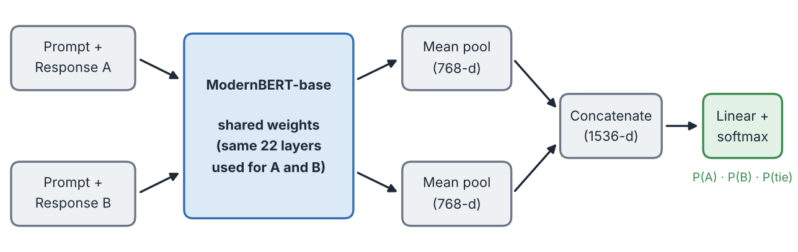
The design is a shared-weight bi-encoder, adapted from the public KerasNLP starter notebook. Each row becomes two strings, Prompt: … Response: … for A and for B. One backbone encodes both; each output is mean-pooled over real tokens (padding masked out, since ModernBERT has no dedicated sentence token); the two 768-d vectors are concatenated and a linear layer (4,611 parameters) outputs three logits. Sharing weights makes the model apply one consistent quality function to both answers, avoids doubling parameters, and makes swapping A and B a valid augmentation. The trade-off is that A and B never attend to each other: they meet only at the final linear layer, so the model is weak at direct, token-level comparison. A joint cross-encoder would fix that but needs roughly 1,300 tokens at the 90th percentile (the sum of the prompt and two response percentiles).
Training setup. Cross-entropy with label smoothing 0.02 (discourages overconfidence, which log loss punishes, and softens noisy labels); AdamW at a learning rate of 2e-5 (small, to preserve pretrained knowledge); 10% linear warm-up then linear decay; fp16 mixed precision; 512 tokens per input; 2 epochs; a stratified 80/20 holdout (45,981 / 11,496 rows) with the best checkpoint chosen by validation log loss. I used a single holdout instead of k-fold because 5 folds would cost 5 × 90 minutes of GPU time. One known weakness: over-long inputs are truncated from the end, which can cut off an answer’s conclusion; keeping the head and tail would be better.

7. Compute: complexity, parallelism and how I managed it
Cost model. Per layer, the projections and feed-forward cost grows linearly with sequence length n (about n·d²), while full self-attention grows with n²·d, so long inputs get expensive quickly; activation memory scales with batch × length. The bi-encoder runs two forward and backward passes per row, so each step processes batch × 2 × length tokens (about 16,400 tokens at batch 16 and 512). Memory is a second constraint. By arithmetic, 150M fp32 parameters take about 0.6 GB (matching the 596 MB checkpoint), AdamW adds two state tensors (1.2 GB) and gradients another 0.6 GB, so about 2.4 GB is fixed before activations. Activations dominate and are why batch size and length were the tuning knobs; a per-GPU batch of 16 at 512 tokens fit in a T4’s 16 GB. I estimated run time from the first 200 steps of each attempt before committing GPU quota:
Configuration | Time per step | Steps (total) | Outcome
900 tokens, batch 8, 1 GPU, 3 epochs | ≈ 1.5 s | 17,244 | ≈ 7 h projected; stopped
512 tokens, batch 16, 1 GPU, 2 epochs | ≈ 1.5 s | 5,748 | ≈ 2.4 h projected; session died twice
512 tokens, batch 32, DataParallel on 2 × T4, 2 epochs | ≈ 1.65 s | 2,874 | ≈ 90 min measured (5,398 s incl. validation)

Step time tracked the number of tokens per step, so the real savings came from cutting total steps threefold (shorter sequences, fewer epochs, larger batches), not from per-step speed. Using both GPUs: a plain PyTorch loop uses one of Kaggle’s two T4s. I wrapped the model in nn.DataParallel, which copies the model to both GPUs on every forward pass, splits a batch of 32 into 16 per GPU, gathers the outputs on GPU 0, computes the loss there and sums gradients back to the primary copy. Measured throughput rose from about 10.7 to about 19 rows/s (roughly 1.8×), better than the 1.3–1.6× I expected, because per-step compute was large relative to synchronisation. I chose DataParallel over DistributedDataParallel (one process per GPU with gradient all-reduce, which scales better and avoids the GPU-0 bottleneck) because DDP is awkward to launch inside an interactive notebook kernel, and I rejected the TPU option because it would have required rewriting the loop for torch_xla or JAX. Inference runs on a single GPU in fp16 with no backward pass, so it needs no parallelism.
Reliability. Interactive sessions were killed twice when my device slept or the connection dropped. I moved long runs to Save & Run All, a server-side batch job independent of the browser, and saved the best checkpoint to disk each time validation improved. GPU quota is a weekly pool, so I avoided leaving idle sessions open and cut scope after the first timing estimate rather than after the run.

8. Deployment under code-competition rules
Training (about 90 minutes, on GPU) and inference are separate notebooks. I saved the base ModernBERT files (config, tokenizer, weights) and the fine-tuned checkpoint as two Kaggle Datasets, so the inference notebook loads everything from local paths and needs no internet. Three issues taught lasting lessons. (1) The checkpoint was saved from the DataParallel wrapper, so every key carried a module. prefix and a strict load_state_dict reported all keys missing; I strip the prefix and keep the strict load, which prints “All keys matched”. The cleaner fix is to save model.module.state_dict(). (2) Notebooks edited interactively worked only because of leftover kernel state; they failed when re-run from a blank kernel until I rebuilt them top to bottom. (3) To confirm the inference code reproduces training, I re-scored 3,000 held-out rows through it and got 1.018, against 1.0136 on the full holdout.

9. Results and error analysis
Validation (1.0136), the inference check (1.018) and the leaderboard (1.0182) agree closely, so the model is not overfitted to my holdout. On the 3,000-row check the model had 48% accuracy and a mean top-class probability of 0.49, meaning it hedges on most rows. It predicted “tie” for only 21% of rows against 31% in the data, and averaging predictions over swapped A/B order changed the loss by just 0.0005, so position is not the problem. Training loss (about 1.005, a running average over the epoch) is close to validation loss (1.014), which points to underfitting rather than overfitting. A concrete failure: for the prompt “I have three oranges today, I ate an orange yesterday. How many oranges do I have?”, answer B (three) is right and A (two) is wrong, yet the model gave about 0.50 to a tie. Judging that needs arithmetic reasoning, which a 150M-parameter encoder reading each answer separately does not do well. Leaderboard ranks on a rolling competition shift as others submit, so the rank is a snapshot.

10. Limitations, next steps and lessons
Limitations: one seed, one holdout split, no ablations (for example ModernBERT vs DeBERTa, or 512 vs 900 tokens), and labels that are inherently noisy.

Would more epochs have helped?
I did not test it, so this is reasoning, not a result. Because the model was underfitting, more training could help, but I expect only a small gain. The learning-rate schedule decays to zero at the end of epoch 2, so a third epoch would need a fresh run with a longer schedule, not a continuation. With about 46,000 noisy training rows, validation loss would probably flatten after a few epochs and then rise as the model starts memorising individual labels. The right way to find out is to log validation loss every epoch and stop early. The larger limits are structural (separate encoding of the two answers and no reasoning ability), which more epochs do not remove.

Next steps, in order of expected value
- A decoder LLM with LoRA/QLoRA, piloted first on a 1.5–3B model to validate the pipeline cheaply before paying for a 7B run.
- A joint cross-encoder input so the model can compare answers directly, plus training on A/B-swapped copies (twice the data, about twice the cost) and head-and-tail truncation.
- Calibration work on the tie class, then an ensemble with the baseline.
Lessons: validate and clean data before modelling; build a cheap baseline to test the pipeline; estimate cost from a short timing run before spending quota; run long jobs as batch jobs; keep train and inference preprocessing identical; and check checkpoint compatibility before relying on it.

